Setting up your “Gradebook”
When setting up a gradebook there are three steps; “Is attendance graded?”, type of score method, and letter grade scale.
- Navigate to your course and click the “Gradebook” link on the left-hand navigation bar. The following page will open
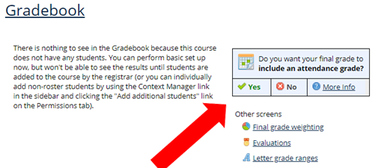
- Step One: “Will the course have an attendance grade?” Select Yes or No to the question “Do you want your final grade to include an attendance grade?
- Step Two: Grading Method
  - Click the “Final grade weighting” link from the image above.
  - Final grade weighting You use the Final Grade Weighting screen to manage how students’ overall grades for the term are determined. You can choose to manually entering students’ scores, or you can have the feature automatically calculate grades, using any of several methods.
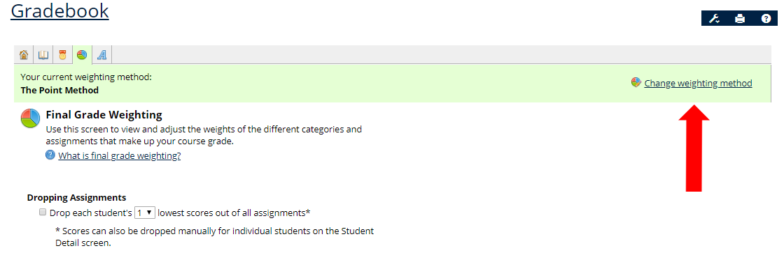

- Click the “Change weighting method” link (See image above)
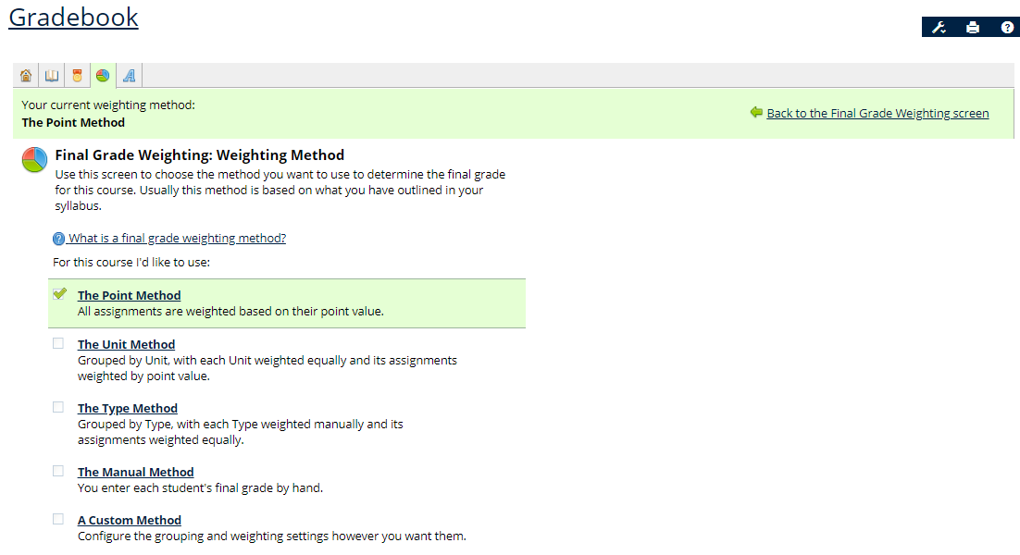
- The various weighting methods are described in the following:
  - The Point Method All items are weighted according to their point values. This is the default method. For Coursework assignments, the point values are set in the Coursework feature. For Gradebook evaluations, point values are set on the Gradebook’s evaluations tab. This won’t require additional configuration.
  - The Unit Method All Coursework units are weighted equally. Within each unit, items are weighted according to their point values. If you have created one or more evaluations, all evaluations are treated like a single unit. Within that unit, individual evaluations are weighted according to their point values. This usually won’t require additional configuration, unless you choose to customize weighting within one or more units, using an exception feature.
  - The Type Method You manually enter a weight for each type, and a weight for all your evaluations, which are treated as a single type. Within each type, all assignments are weighted equally. Individual evaluations are weighted according to their point values.
  - The Manual Method There is no automatic grade calculation—instead, you manually enter each student’s grade.
- Step Three: Selecting Grade Ranges
  - You use the Letter Grade Configuration screen to manage the definition for each of your letter grades (for example, an A could be defined as 90 to 100%, a B as 80 to 89%, and so on). There are several grading-scale options from which you can choose.
  - Click the “Change to:” drop down menu and select the appropriate grade range
    - Basic ABCD is the grade range 90 – 100%, 80 – 89.9%, etc.

