How to email students

In a course shell on the left-hand navigation bar is a link named “Roster”. Instructors can use the roster to email their respective students. In the live semester courses students are automatically populated in the course.
- How to send an email. Locate and click on the “Roster” link on the left-hand navigation bar.
- The “Roster” window will open. There are both “Students” and “Faculty” profiles listed. Each has a square selection box. Select each individual that will receive the email. To select all that are listed locate the “Select All” check box near the right upper corner of the roster page.
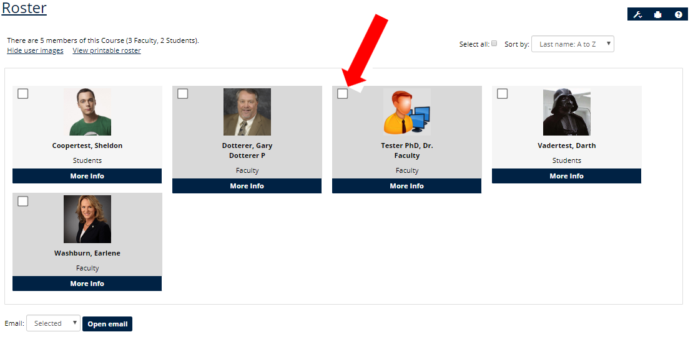
- Click the “Open email” button
- Once the email window opens. Notice all who were selected are listed under the Recipients heading.
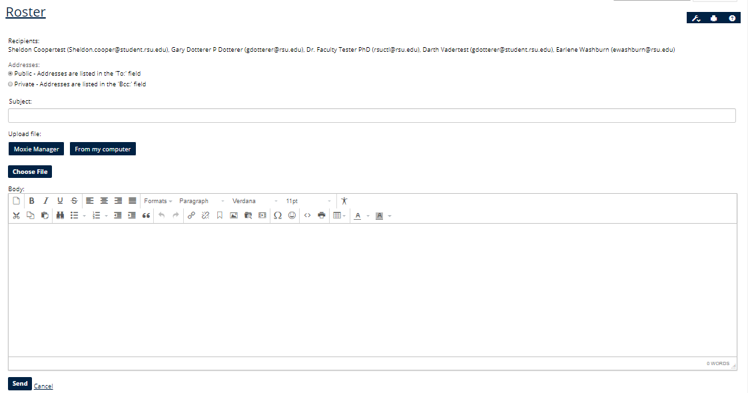
- Begin drafting the email by adding a subject and body. Attachments can be included
- Click the “Send” button.
When sending any email, make sure you selected to send the email to yourself!

