Adding an Online Test Format
Once you have navigated to the coursework area, to add an assignment.
- Click on the “Add an Assignment” link
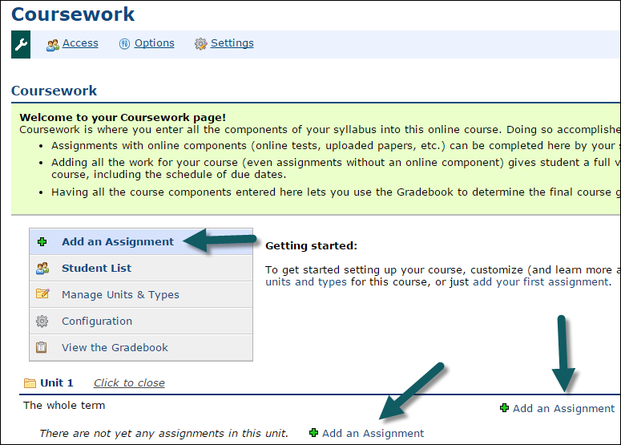
The Assignment window opens
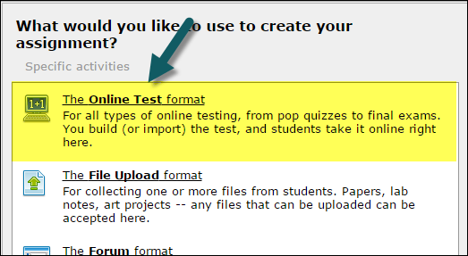
- Step One: On the General Assignment Information section complete the following:
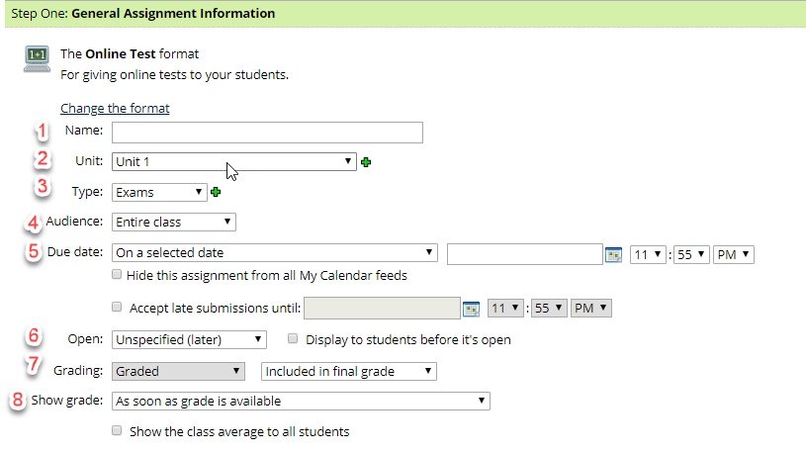
- Name - Add a meaningful name for the assignment
- Unit - Click the dropdown arrow to select a “Unit” or click the to add a new unit (see Creating a Unit
- Type - There are two dropdown menus for Type. The first is to make the assignment required, extra credit or optional. The second Type is to put it in the proper category.
- Click the first drop down menu and select the appropriate type.
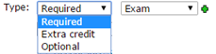
- Click the second drop down menu and select the appropriate type or click the to create a new type (see Creating types)

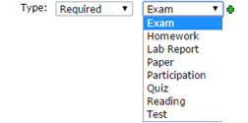
- “Audience” would be “Entire Class.” Faculty have the option to choose “Selected Students” under special circumstances, but standard discussion forums use the “Entire Class.”
- Due Date – type in the due date (m/d/yyyy) or click on the calendar to select a date. Enter a time (i.e. hour, minutes, AM/PM). To add the assignment to the calendar, click the box next to “Show this due date in the course calendar.”
  - Calendar icon: - Clicking on the calendar icon . The calendar pop up window will appear.
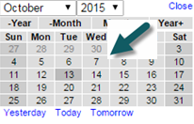
- Accept late submissions – enter the date and time if late submissions will be allowed.
To set the date you can use the calendar icon as mentioned above.
- Open: select one of the following options to open the Discussion Forum.
Immediately Now
Unspecified (Later)
“Based on Rules I define” select this option
New options will appear that allows faculty to indicate that if a date has passed or specific assignment has been completed, then the discussion will open for the student. Faculty will want to set “When a date” (by clicking the dropdown arrow) and select “a date” which will be immediately prior to the date the faculty want the students to see the forum. Faculty will want to complete the remainder of the date and time.
- Grading – drop down the menu and select Graded, if it is a graded assignment; Graded (Rubric) if it will be graded using a rubric; Credit/No Credit if this is a pass/fail type assignment; or Not graded if there will be no grade for the assignment. If Graded or Graded (Rubric) are selected, it is necessary to assign a point value.
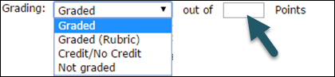
- Show grade – specifies when students are allowed to see the grade for the assignment.
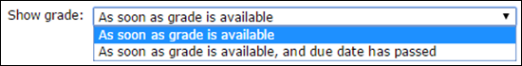
- Step Two is for setting the number of files required and the maximum number of files that will be accepted for the assignment. Expand the section by clicking on the down arrow next to the step.
- Step Two: Online Assignment Options (Optional)

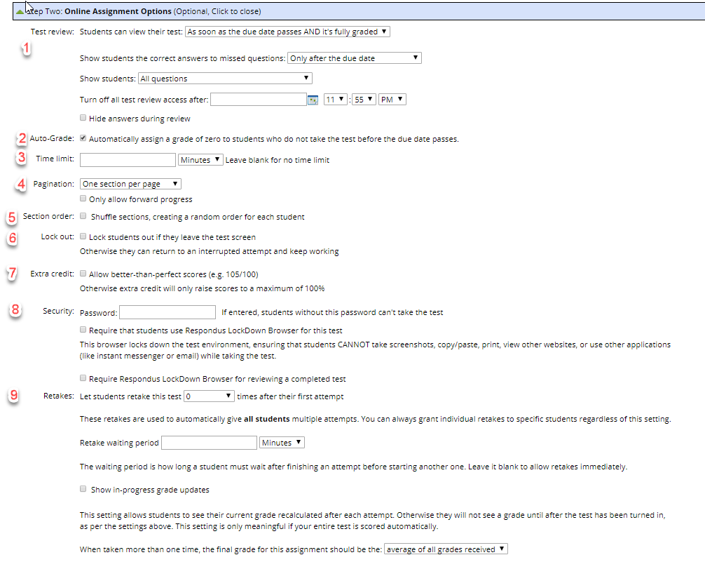
- Test Review there are three areas to consider.
  - Students can view their test has six options. Select the appropriate option from the list below:
    - As soon as the due date passes and it is fully graded
    - Immediately after each attempt
    - As soon as they turn it in
    - As soon as it is fully grades
    - As soon as the due date passes
    - Never
  - Show students the correct answers to missed questions. There are three options.
    - Only after the due date
    - Anytime they can review the test
    - Never
  - Turn off test review access after a certain date and time (choose date and time). You can use the calendar icon to select the date, time, minutes, and AM or PM.
- Auto Grade: A grade of zero will be recorded if there is no take and the due date has passed
- Time limit: Choose time limit in
  - minutes
  - hours
  - days
  - leave form field blank for unlimited time
- Pagination: choose
  - Once section per page
  - One question per page
  - Five questions per page
  - None (all on one page)
- Section order: Check box to shuffle sections, creating a random order for each student
- Lock out: check box to lock students out if they leave the test screen (otherwise they can return to an interrupted attempt and keep working)
- Extra credit: Check the box to allow better than perfect scores
- Security: choose
  - Password – If entered in the form field, student without the password can’t take the test
  - Check the box to require students use Jenzabar Lock down Browser for this test.
  - Check the box to require the Jenzabar Lockdown browser for reviewing a completed test.
- Retakes:
  - Let students retake this test (use the dropdown arrow to choose the number) times after their first attempt.
  - Retake waiting period ( use the dropdown box to choose number)in minutes, hours, days.
  - Check the box to show in-progress grade updates
  - When taken more than one time, the final grade for this assignment should be the:
    - Average of all grades received
    - Highest grade received
    - Last grade received
- Step Three provides an area for the assignment description and instructions.
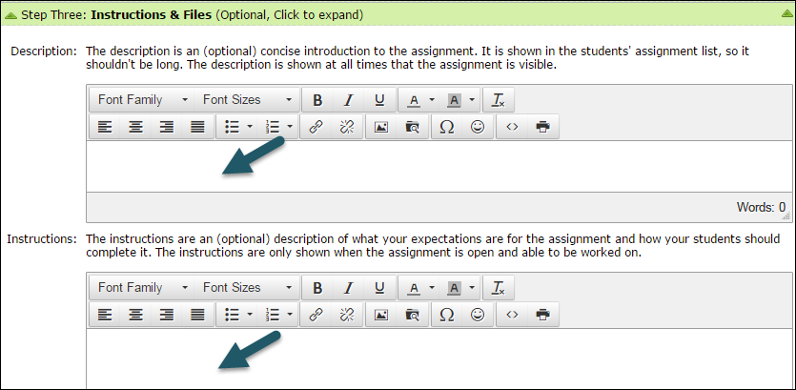
- Click on “Save your new assignment” or cancel.

