Adding a File Upload Assignment

- Click on the “Add an Assignment” link

The Assignment window opens
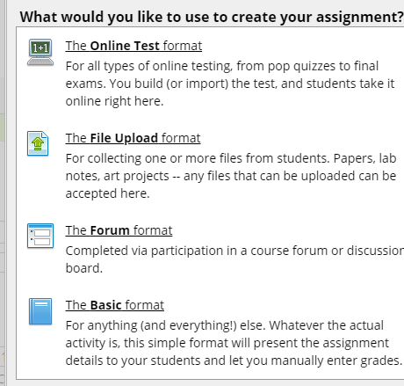
- Select the “File Upload Format” assignment
- Begin completing the “Step One: General Assignment Information”

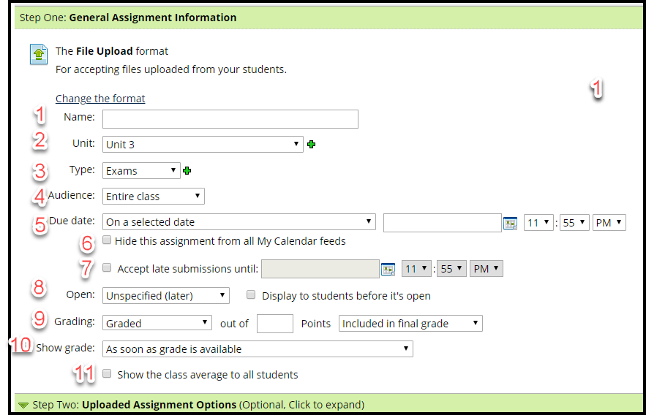

- Name - Add a meaningful assignment name.
- Unit - Click the dropdown arrow to select a “Unit” or click the to add a new unit. (This will be the “Unit” as you have previously named them. Your assignment will be linked to the “Unit” that you select in this step.)
- Type – Select the type of assignment that you are building; Exam, Homework, Lab Report, Paper, etc. The “Type” of assignment is as you named your “Types” (assignments) earlier.
- Audience – Select “Entire Class.” At a later date, you may need to assignment additional work to specific students and that is when you would select “Selected Students” as the “Audience.”
- Due Date: From the dropdown arrow, you have two options; “On a selected date” or “Based on Rules I define.”

Due Date – type in the due date (m/d/yyyy) or click on the calendar to select a date. Enter a time (i.e. hour, minutes, AM/PM). By default, most due dates close at 11:55 PM.
  - Calendar icon: - Clicking on the calendar icon . The calendar pop up window will appear.
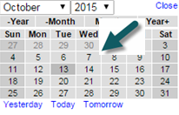
- Hide this assignment from all My Calendar feeds - Unless this box is checked, all assignments will automatically populate in the calendar. You will seldom ever want to check this box to hide an assignment.
- Accept late submissions – enter the date and time, if late submissions will be allowed.
To set the date you can use the calendar icon as mentioned above.
- Open: - select
  - “Immediately (Now)”: to immediately open the assignment;
  - “Unspecified (Later)”, if you are not sure what date; or
  - “Based on Rules I Define” to have the assignment open on a particular date and time. Check the box “Display to students before it’s open,” if you want students to see that they have an assignment coming up.
- Grading – drop down the menu and select Graded, if it is a graded assignment; Graded (Rubric) if it will be graded using a rubric; Credit/No Credit if this is a pass/fail type assignment; or Not graded if there will be no grade for the assignment. If Graded or Graded (Rubric) are selected, it is necessary to assign a point value.
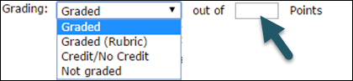
- Show grade – specifies when students are allowed to see the grade for the assignment.
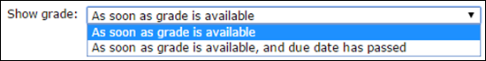
- Step Two is for setting the number of files required and the maximum number of files that will be accepted for the assignment. Expand the section by clicking on the down arrow next to the step.
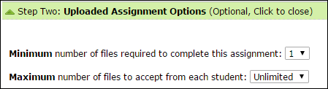
- Step Three provides an area for the assignment description and instructions.
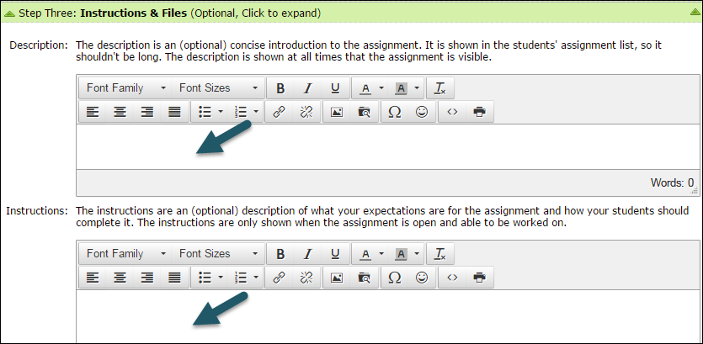
- Click on Save your new assignment to save the assignment.

