Adding a Discussion Forum
In this Learning Management System (LMS) there are two types of discussion forums. A graded discussion or a non-graded forum such as a “Q&A” area for student questions. To create a discussion forum it is a two-step process. The first step is to create the actual forum and step two create the assignment which will link the assignment with the respective forum.
Step One:
- Locate the “Forums” link on the left-hand navigation bar.
- Once the new window opens the forum must be created. It is a good idea to categorize the forums to keep an organizational structure. For example: graded and non-graded forums, weekly forums, project forums, etc.
- How to “Add a category”, complete the following steps:
  - Select “Edit Forums”
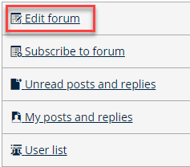
  - Click on the “Add Category” button
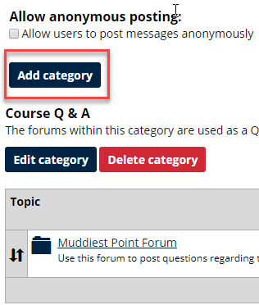
  - To add a category
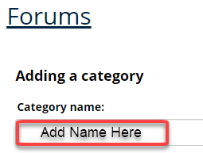
  - Add a Description.
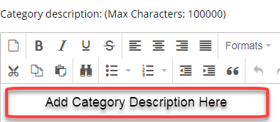
  - Topic ordering method
    - Arrange topics: should remain set at “Manually”
    - Pruning: Remove Post after: set to “DO NOT REMOVE”
    - Access: should remain set for “Available to all users and guests”
    - Select “Save Category” in the blue box.
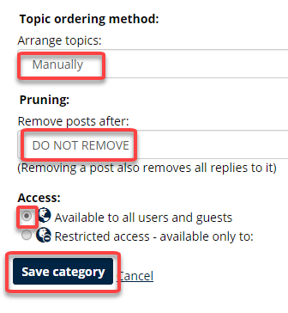

- Adding “Topics”. Topics are the title name of each forum you create. For example’ Category is “Trees” Topics could be “Tree Height”, “Tree Type”, etc.
  - Locate the category that you want to add a forum topic.
  - Select “Add Topic”
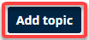
  - Provide the “Topic Name” and detailed description for your students to discuss
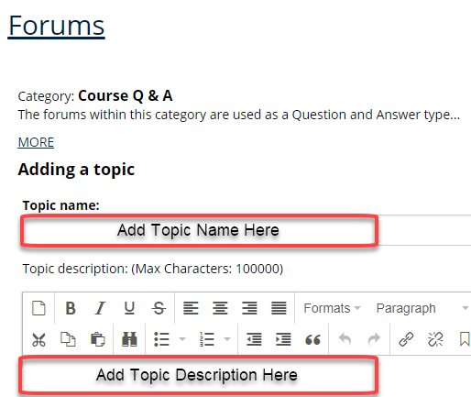
  - “Activation” “Start:” Display Now “End:” No end date
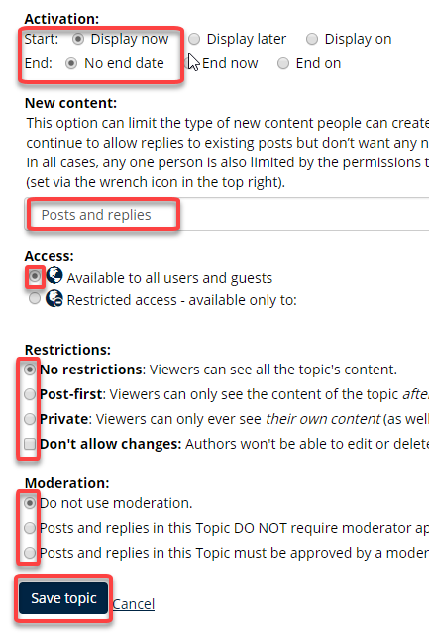
  - New Content: “Post and replies” should remain populated in the options box
  - Access: should remain “Available to all users and guests”
  - Restrictions: should remain “No restrictions”
  - Moderation: “Do not use moderation” should remain selected unless you want to approve both posts and replies in a discussion topic.
  - Select, “Save Topic” in the blue box.

Proceed to The Second step which is building the assignment in the “Coursework” area and linking the assignment to the specific discussion forum. See instructions on page 2 below:

Step Two:
- Click on the “Coursework” link on the left-hand navigation bar
- Once the page opens select “Add an Assignment” (see image below)
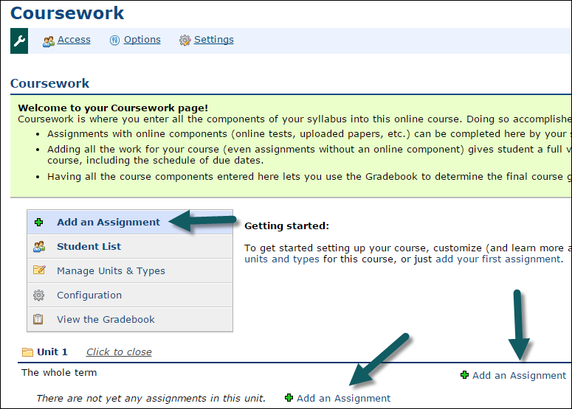
- Choose “The Forum Format” to add a discussion
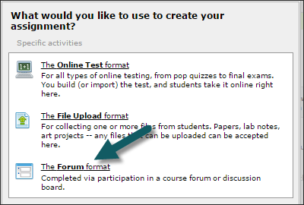
- The window below will appear. There are three steps to create an assignment type discussion forum
- Step one: General Assignment Information
- Step two: Forums Assignment Options
- Step three: Instructions & Files

- Form Field names and descriptions
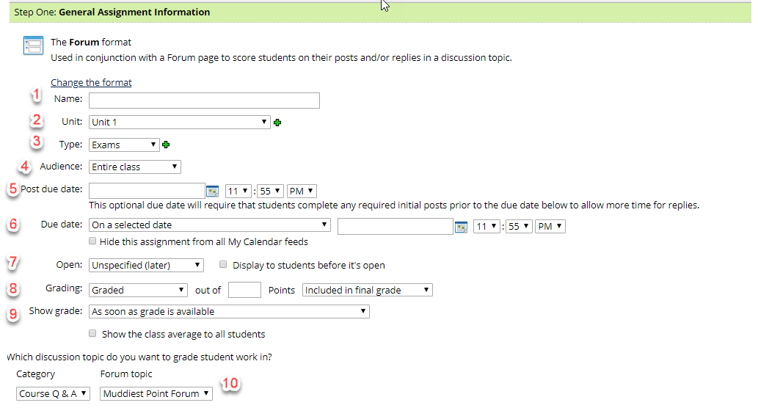
- Name: - Add a “Name” for the forum topic
- Unit: – Since you are creating a discussion forum you will want to change the type from Exam (the default) to “participation.” Click the drop-down arrow and select “Discussions.”
- Type: – Click the drop-down arrow and select the type of assignment. (see list from the drop-down menu)
- Audience: – Faculty have the option to chose “Selected Students” under special circumstances, or the “Entire Class.” Select the appropriate item.
- Post due date: – When using this setting, students must post their initial post no later than the selected date and time.
- Due date: – The “Due Date” dropdown button offers “On a Selected Date” or “Before the end of the Course.” Select a due date.
Enter a time (i.e. hour, minutes, AM/PM). The assignment will populate in the calendar unless faculty desire to “Hide this assignment from all My Calendar feeds” by selecting the action button preceding the same name. (Best practices consider no selecting this option. The entry will be added to the student’s calendar.
Figure 3. Add a due date and time (hour & minute, am/pm)
- Open: select one of the options below in the image.

  - If selecting “Based on Rules I define” new options will appear that allows faculty to indicate conditions. For example; if an assignment due date has passed or specific assignment has been completed, the next assignment would open.
- Grading options are: Graded, Graded (Rubric), and Credit/No Credit or “not graded”.
- Add points, choose whether to show grades and class average.
- Show Grade: Using this setting you determine if and when students are able to see their grade.
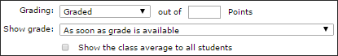
- Step Two: Forums Assignment Options
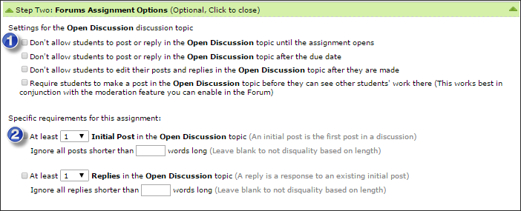
- Choose specific “settings for the discussion” based on faculty preference by checking the applicable boxes.
  - Don’t allow students to post or reply until assignment opens
  - Don’t allow student to post or reply after the due date
  - Don’t allow students to edit their post and replies after they are made
  - Require students to make a post before they can see other students’ work there.
- Choose “specific requirements for this assignment”
- Requirements for initial posts in the discussion
- Requirements for the number of replies required.

- Step Three: Instructions and Files (this section is optional)
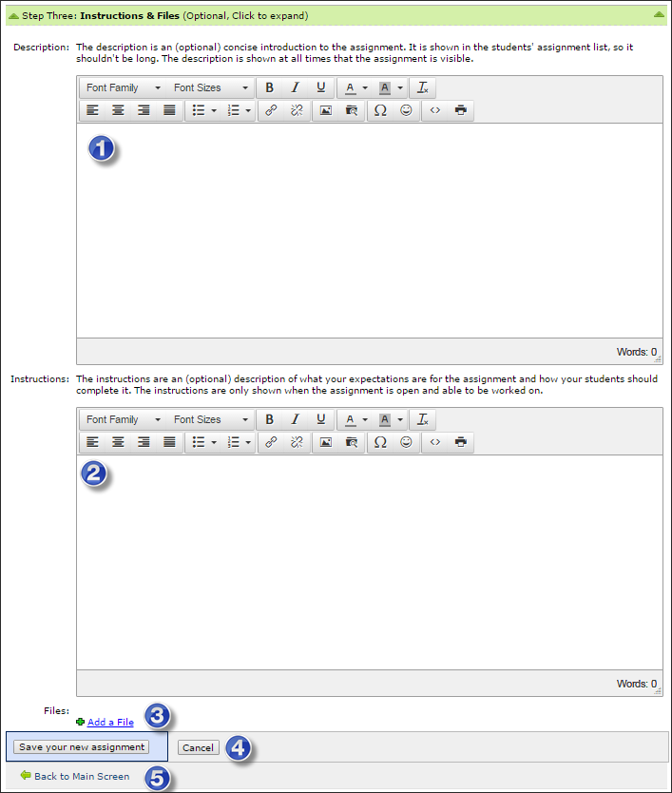

  - Description is optional. If a description is provided, it should be brief and will automatically populate in the “At A Glance” page.
  - The instructions are descriptions of what your expectations are for the assignment.
  - Select the “Save your new assignment”.
  - Click the link “Back to Main Screen”

