Adding a Basic Format Assignment

The Basic format can be used for any assignment or assessment that cannot be tracked using the online-test or upload-file formats. For example, you might use a basic format for creating an assignment that will be manually graded, such as an oral presentation. You might also use this format for an assignment that is completed and graded in a third-party application, such as MyMath Lab. Note: some third-party applications can be integrated with eLearning through an LTI, which would allow the grades to transfer automatically.
- Click on the “Add an Assignment” link
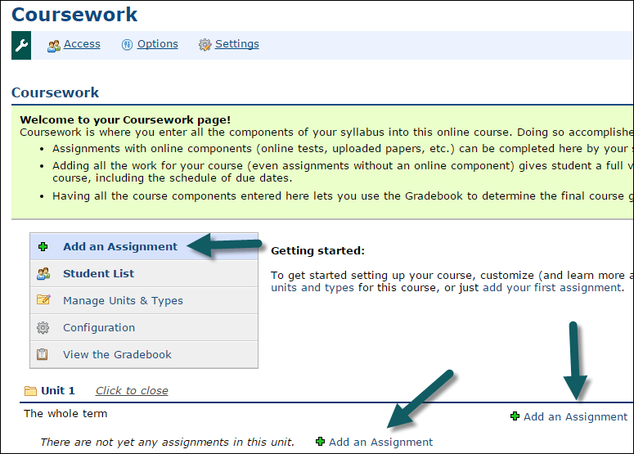
The Assignment selection window opens.
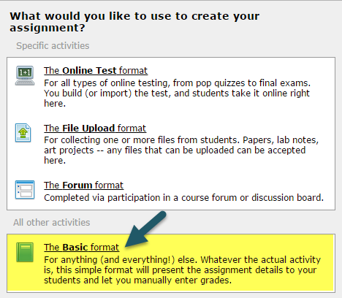
- Select the Basic format
There are three sections (steps) where assignment settings and instruction may be defined.

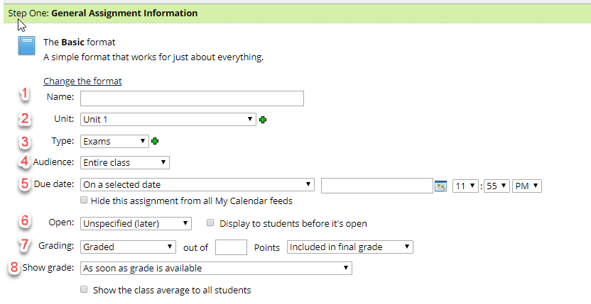
- Step One: On the General Assignment Information section complete the following:
- Name: - Add a meaningful name for the assignment
- Unit - Click the dropdown arrow to select a “Unit” or click the to add a new unit (see Creating a Unit
- Type - There are two dropdown menus for Type. The first is to make the assignment required, extra credit or optional. The second Type is to put it in the proper category.
- Click the first drop down menu and select the appropriate type.
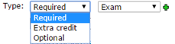
- Click the second drop down menu and select the appropriate type or click the to create a new type (see Creating types)
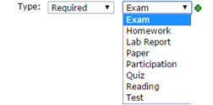
- “Audience” would be “Entire Class.” Faculty have the option to choose “Selected Students” under special circumstances, but standard discussion forums use the “Entire Class.”
- Due Date – type in the due date (m/d/yyyy) or click on the calendar to select a date. Enter a time (i.e. hour, minutes, AM/PM). To add the assignment to the calendar, click the box next to “Show this due date in the course calendar.”
- Open: select one of the following options to open the Discussion Forum.
Immediately Now
Unspecified (Later)
“Based on Rules I define” select this option
New options will appear that allows faculty to indicate that if a date has passed or specific assignment has been completed, then the discussion will open for the student. Faculty will want to set “When a date” (by clicking the dropdown arrow) and select “a date” which will be immediately prior to the date the faculty want the students to see the forum. Faculty will want to complete the remainder of the date and time.
- Grading – drop down the menu and select Graded, if it is a graded assignment; Graded (Rubric) if it will be graded using a rubric; Credit/No Credit if this is a pass/fail type assignment; or Not graded if there will be no grade for the assignment. If Graded or Graded (Rubric) are selected, it is necessary to assign a point value.
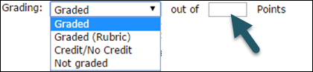
- Show grade – specifies when students are allowed to see the grade for the assignment.
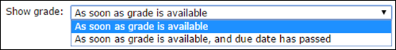
- Click Save your new assignment.
- Step Two (optional) should be completed if learning tool integration is available for a third-party application, such as MyMath Lab. You may also use this area to add details about material that students should read.
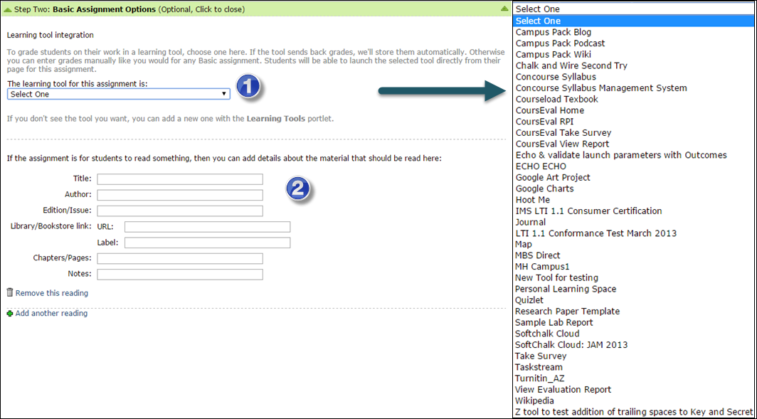
- Drop down the list and select the appropriate learning tool from the list
- Enter reading material information
- Step Three provides an area for the assignment description and instructions.
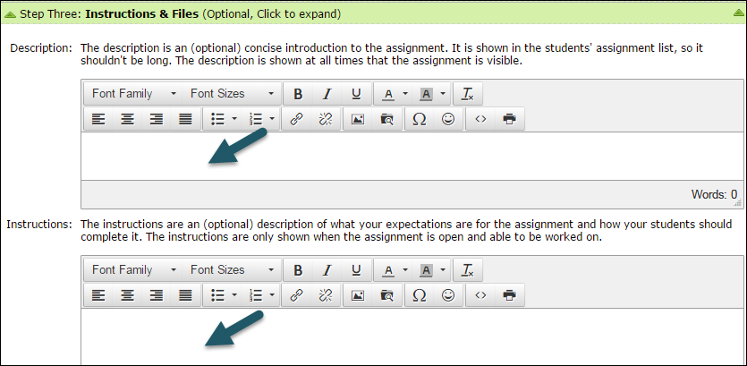
- Click on Save your new assignment to save the assignment.

