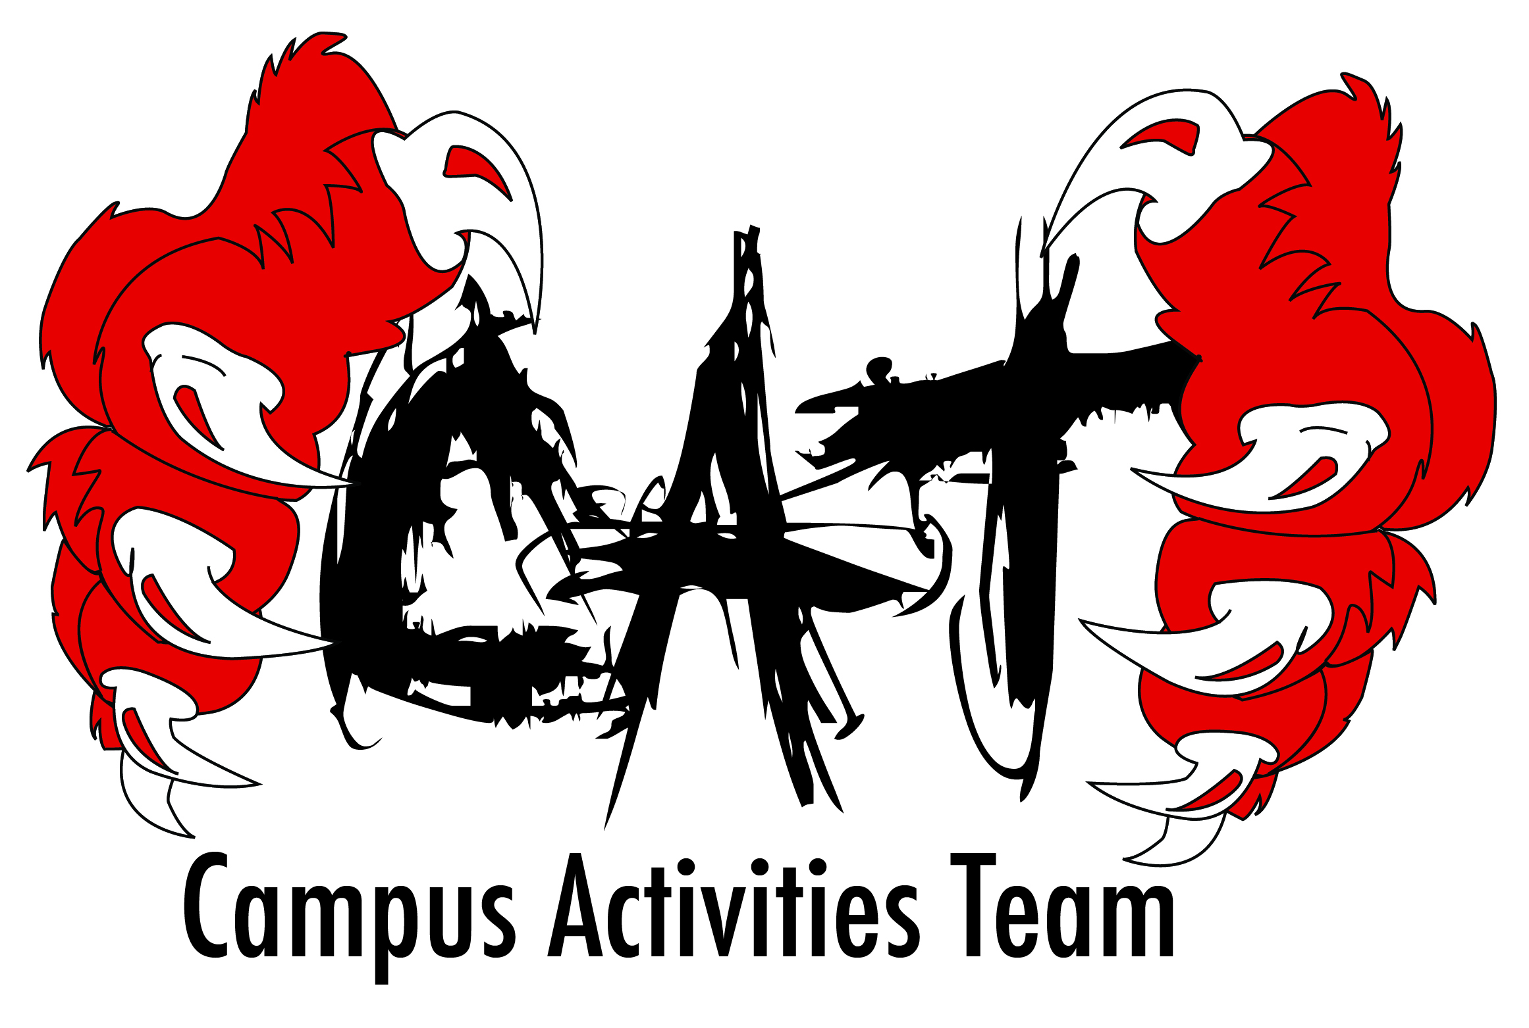

2014-2015 Application

Name______________________________________
Date returned________________________________
Interview Date__________________________________
Previous position held ___________________________

Last name____________________________ First name__________________________

Student ID____________________________ Classification________________________
Email Address________________________________________________________________

Local Address_________________________________________________________________
Cell number__________________________ Work number________________________

Permanent Address____________________________________________________________
City_________________________________ State_____ Zip_______________

Major_______________________________ Cumulative GPA______________________
NOTE: Applicants must have a cumulative GPA of 2.5 and maintain a 2.5 throughout their term.
Please describe why you want to be a member of the Campus Activities Team in 100 words or less:
____________________________________________________________________________
____________________________________________________________________________
____________________________________________________________________________
____________________________________________________________________________
____________________________________________________________________________
____________________________________________________________________________

What activities and organizations have you been part of in the past (please list offices held):
____________________________________________________________________________
____________________________________________________________________________
____________________________________________________________________________
____________________________________________________________________________
What qualities do you possess that would make you a successful member of CAT?
____________________________________________________________________________
____________________________________________________________________________
____________________________________________________________________________

Please list two references:
Name_______________________________ Title_______________________________
Phone Number________________________ Relationship_________________________

Name_______________________________ Title_______________________________
Phone Number________________________ Relationship_________________________

Qualifications:
- Must be a full time student in good standing with the university.
- Must have a 2.5 cumulative GPA and maintain a 2.5 throughout the term of service.
Responsibilities:
- Attend mandatory, weekly meetings of the RSU Campus Activities Team. Meeting times will be set after members are selected.
- Attend bi-weekly meetings with your advisor.
- Plan, execute, and evaluate campus events with the input and assistance of the TEAM.
- Prepare program proposals (4 weeks in advance) and evaluations (1-2 weeks after event) to present at CAT meetings.
- Attend ALL CAT training sessions (2-3 per year) and all CAT events that don’t conflict with classes.
Agreement of Responsibilities:
I understand that if I am selected to the Campus Activities Team I have the aforementioned responsibilities to uphold during the 2014-2015 academic year.
I also agree to release my grades to the Office of Student Affairs to ensure that I meet the minimum GPA requirements.
Signature____________________________ Date_______________________________
Position Descriptions 2014-2015
INSTRUCTIONS: Please select three (3) positions in which you are most interested in applying. Then number your choices (1=highest/ 3=lowest).
_____Diversity and Volunteerism Director– This position will help plan events to educate the student body about diverse cultures and cultural issues. They will also plan community service projects for students to participate in. Examples of past events include Salsa, Hispanic Heritage Month, Readers are Leaders, and Women’s History events.

_____Entertainment Director– This position is responsible for planning exciting events for students including concerts, comedians, and movie nights. This person also helps choose the talent for Late Night Breakfast.

_______Fun & Games Director– This position is responsible for planning events that are purely fun. Past events include RSU Skate Night and game show. Fun and Games will also plan Big Thing Day.

_____Graphics & Marketing Co-Director – This is a two-person position responsible for creating graphics and marketing events to the campus community. They will assist other directors in creating marketing plans, and will be responsible for organizing the CAT at Early Enrollment Day, Destination RSU, Big Tent Day, and other such promotional events.

_____Logistics Director– This position is responsible for the weekly meeting agenda, meeting minutes, and reserving rooms and equipment on campus. This position is also responsible for CAT’s ‘food day’ events.

_____Social Issues Director– This position is responsible for educational programming about issues important to college students. Past events include OctSoberfest, voter registration drives, recycle drives and Safe Spring Break week.

